**PERKEMBANGAN TRANSISTOR**

**PADA PROCESSOR INTEL**



Nama : Intan Fitri R

NRP : 2110181005

Kelas : D4 IT A

**POLITEKNIK ELEKTRONIKA NEGERI SURABAYA**

**A. Pengertian Transistor**

Transistor adalah alat semikonduktor yang dipakai sebagai penguat, sebagai sirkuit pemutus dan penyambung (switching), stabilisasi tegangan, modulasi sinyal atau sebagai fungsi lainnya.

Pada umumnya, transistor memiliki 3 terminal, yaitu Basis (B), Emitor (E) dan Kolektor (C). Tegangan yang di satu terminalnya misalnya Emitor dapat dipakai untuk mengatur arus dan tegangan yang lebih besar daripada arus input Basis, yaitu pada keluaran tegangan dan arus output Kolektor.

Transistor merupakan komponen yang sangat penting dalam dunia elektronik modern. Dalam rangkaian analog, transistor digunakan dalam amplifier (penguat). Rangkaian analog melingkupi pengeras suara, sumber listrik stabil (stabilisator) dan penguat sinyal radio. Dalam rangkaian-rangkaian [digital](https://id.wikipedia.org/wiki/Digital" \o "Digital), transistor digunakan sebagai [saklar](https://id.wikipedia.org/wiki/Saklar" \o "Saklar) berkecepatan tinggi. Beberapa transistor juga dapat dirangkai sedemikian rupa sehingga berfungsi sebagai logicgate, memori dan fungsi rangkaian-rangkaian lainnya.

**B. Tabel Perkembangan Jumlah Transistor:**

|  |  |  |  |  |  |
| --- | --- | --- | --- | --- | --- |
| [Intel 4004](https://en.wikipedia.org/wiki/Intel_4004" \o "Intel 4004) | 2,300 | 1971 | [Intel](https://en.wikipedia.org/wiki/Intel" \o "Intel) | 10,000 nm | 12 mm² |
| [Intel 8008](https://en.wikipedia.org/wiki/Intel_8008" \o "Intel 8008) | 3,500 | 1972 | Intel | 10,000 nm | 14 mm² |
| [Intel 8080](https://en.wikipedia.org/wiki/Intel_8080" \o "Intel 8080) | 4,500 | 1974 | Intel | 6,000 nm | 20 mm² |
| [Intel 8085](https://en.wikipedia.org/wiki/Intel_8085" \o "Intel 8085) | 6,500 | 1976 | Intel | 3,000 nm | 20 mm² |
| [Intel 8086](https://en.wikipedia.org/wiki/Intel_8086" \o "Intel 8086) | 29,000 | 1978 | Intel | 3,000 nm | 33 mm² |
| [Intel 8088](https://en.wikipedia.org/wiki/Intel_8088" \o "Intel 8088) | 29,000 | 1979 | Intel | 3,000 nm | 33 mm² |
| [Intel 80186](https://en.wikipedia.org/wiki/Intel_80186" \o "Intel 80186) | 55,000 | 1982 | Intel | 3,000 nm | 60 mm² |
| [Intel 80286](https://en.wikipedia.org/wiki/Intel_80286" \o "Intel 80286) | 134,000 | 1982 | Intel | 1,500 nm | 49 mm² |
| [Intel 80386](https://en.wikipedia.org/wiki/Intel_80386" \o "Intel 80386) | 275,000 | 1985 | Intel | 1,500 nm | 104 mm² |
| [Intel i960](https://en.wikipedia.org/wiki/Intel_i960" \o "Intel i960) | 250,000[[15]](https://en.wikipedia.org/wiki/Transistor_count" \l "cite_note-15) | 1988 | Intel | 600 nm |  |
| [Intel 80486](https://en.wikipedia.org/wiki/Intel_80486" \o "Intel 80486) | 1,180,235 | 1989 | Intel | 1000 nm | 173 mm² |
| [Pentium](https://en.wikipedia.org/wiki/Intel_P5" \o "Intel P5) | 3,100,000 | 1993 | Intel | 800 nm | 294 mm² |
| [Pentium Pro](https://en.wikipedia.org/wiki/Pentium_Pro" \o "Pentium Pro) | 5,500,000[[17]](https://en.wikipedia.org/wiki/Transistor_count" \l "cite_note-17) | 1995 | Intel | 500 nm | 307 mm² |
| [Pentium II](https://en.wikipedia.org/wiki/Pentium_II" \o "Pentium II) Klamath | 7,500,000 | 1997 | Intel | 350 nm | 195 mm² |
| [Pentium II](https://en.wikipedia.org/wiki/Pentium_II" \o "Pentium II) Deschutes | 7,500,000 | 1998 | Intel | 250 nm | 113 mm² |
| [Pentium III](https://en.wikipedia.org/wiki/Pentium_III" \o "Pentium III) Katmai | 9,500,000 | 1999 | Intel | 250 nm | 128 mm² |
| [Pentium III](https://en.wikipedia.org/wiki/Pentium_III" \o "Pentium III) Coppermine | 21,000,000 | 2000 | Intel | 180 nm | 80 mm² |
| [Pentium II](https://en.wikipedia.org/wiki/Pentium_II" \o "Pentium II) Mobile Dixon | 27,400,000 | 1999 | Intel | 180 nm | 180 mm² |
| [Pentium III](https://en.wikipedia.org/wiki/Pentium_III" \o "Pentium III) Tualatin | 45,000,000 | 2001 | Intel | 130 nm | 81 mm² |
| [Pentium 4](https://en.wikipedia.org/wiki/Pentium_4" \o "Pentium 4) Willamette | 42,000,000 | 2000 | Intel | 180 nm | 217 mm² |
| [Pentium 4](https://en.wikipedia.org/wiki/Pentium_4" \o "Pentium 4) Northwood | 55,000,000 | 2002 | Intel | 130 nm | 145 mm² |
| [Pentium 4](https://en.wikipedia.org/wiki/Pentium_4" \o "Pentium 4) Prescott | 112,000,000 | 2004 | Intel | 90 nm | 110 mm² |
| [Pentium 4](https://en.wikipedia.org/wiki/Pentium_4" \o "Pentium 4) Prescott-2M | 169,000,000 | 2005 | Intel | 90 nm | 143 mm² |
| [Pentium 4](https://en.wikipedia.org/wiki/Pentium_4" \o "Pentium 4) Cedar Mill | 184,000,000 | 2006 | Intel | 65 nm | 90 mm² |
| [Pentium D](https://en.wikipedia.org/wiki/Pentium_D" \o "Pentium D) Smithfield | 228,000,000 | 2005 | Intel | 90 nm | 206 mm² |
| [Pentium D](https://en.wikipedia.org/wiki/Pentium_D" \o "Pentium D) Presler | 362,000,000 | 2006 | Intel | 65 nm | 162 mm² |
| [Atom](https://en.wikipedia.org/wiki/Intel_Atom" \o "Intel Atom) | 47,000,000 | 2008 | Intel | 45 nm | 24 mm² |
| [Itanium 2](https://en.wikipedia.org/wiki/Itanium_2" \o "Itanium 2) McKinley | 220,000,000 | 2002 | Intel | 180 nm | 421 mm² |
| [Core 2 Duo](https://en.wikipedia.org/wiki/Core_2_Duo" \o "Core 2 Duo) Conroe | 291,000,000 | 2006 | Intel | 65 nm | 143 mm² |
| [Core 2 Duo](https://en.wikipedia.org/wiki/Core_2_Duo" \o "Core 2 Duo) Allendale | 169,000,000 | 2007 | Intel | 65 nm | 111 mm² |
| [Itanium 2](https://en.wikipedia.org/wiki/Itanium_2" \o "Itanium 2) Madison 6M | 410,000,000 | 2003 | Intel | 130 nm | 374 mm² |
| [Atom](https://en.wikipedia.org/wiki/Intel_Atom" \o "Intel Atom) "Medfield" | 432,000,000[[18]](https://en.wikipedia.org/wiki/Transistor_count" \l "cite_note-18) | 2012 | Intel | 32 nm | 64 mm² |
| [Core 2 Duo](https://en.wikipedia.org/wiki/Core_2_Duo" \o "Core 2 Duo) Wolfdale 3M | 230,000,000 | 2008 | Intel | 45 nm | 83 mm² |
| [Itanium 2](https://en.wikipedia.org/wiki/Itanium_2" \o "Itanium 2) with 9 [MB](https://en.wikipedia.org/wiki/Mebibyte" \o "Mebibyte) cache | 592,000,000 | 2004 | Intel | 130 nm | 432 mm² |
| [Core 2 Duo](https://en.wikipedia.org/wiki/Core_2_Duo" \o "Core 2 Duo) Wolfdale | 411,000,000 | 2007 | Intel | 45 nm | 107 mm² |
| [Core i7](https://en.wikipedia.org/wiki/Core_i7" \o "Core i7) (Quad) | 731,000,000 | 2008 | Intel | 45 nm | 263 mm² |
| Quad-core + [GPU](https://en.wikipedia.org/wiki/Graphics_processing_unit" \o "Graphics processing unit) [Core i7](https://en.wikipedia.org/wiki/Sandy_Bridge_(microarchitecture)" \o "Sandy Bridge (microarchitecture)) | 1,160,000,000 | 2011 | Intel | 32 nm | 216 mm² |
| Six-core [Core i7](https://en.wikipedia.org/wiki/Gulftown_(microprocessor)" \o "Gulftown (microprocessor)) (Gulftown) | 1,170,000,000 | 2010 | Intel | 32 nm | 240 mm² |
| Quad-core + GPU [Core i7 Ivy Bridge](https://en.wikipedia.org/wiki/Ivy_Bridge_(microarchitecture)" \o "Ivy Bridge (microarchitecture)) | 1,400,000,000 | 2012 | Intel | 22 nm | 160 mm² |
| Quad-core + GPU [Core i7 Haswell](https://en.wikipedia.org/wiki/Haswell_(microarchitecture)" \o "Haswell (microarchitecture)) | 1,400,000,000[[24]](https://en.wikipedia.org/wiki/Transistor_count" \l "cite_note-anandtech-24) | 2014 | Intel | 22 nm | 177 mm² |
| Dual-core [Itanium 2](https://en.wikipedia.org/wiki/Itanium_2" \o "Itanium 2) | 1,700,000,000[[25]](https://en.wikipedia.org/wiki/Transistor_count" \l "cite_note-25) | 2006 | Intel | 90 nm | 596 mm² |
| Quad-core + GPU GT2 [Core i7 Skylake K](https://en.wikipedia.org/wiki/Skylake_(microarchitecture)" \o "Skylake (microarchitecture)) | 1,750,000,000 | 2015 | Intel | 14 nm | 122 mm² |
| Six-core [Core i7 Ivy Bridge E](https://en.wikipedia.org/wiki/Ivy_Bridge_(microarchitecture)" \o "Ivy Bridge (microarchitecture)) | 1,860,000,000 | 2013 | Intel | 22 nm | 256 mm² |
| Dual-core + GPU Iris [Core i7 Broadwell-U](https://en.wikipedia.org/wiki/Broadwell_(microarchitecture)" \o "Broadwell (microarchitecture)) | 1,900,000,000[[26]](https://en.wikipedia.org/wiki/Transistor_count" \l "cite_note-techreport-26) | 2015 | Intel | 14 nm | 133 mm² |
| Six-core [Xeon](https://en.wikipedia.org/wiki/Xeon" \o "Xeon) 7400 | 1,900,000,000 | 2008 | Intel | 45 nm | 503 mm² |
| Quad-core Itanium [Tukwila](https://en.wikipedia.org/wiki/Tukwila_(processor)" \o "Tukwila (processor)) | 2,000,000,000[[27]](https://en.wikipedia.org/wiki/Transistor_count" \l "cite_note-27) | 2010 | Intel | 65 nm | 699 mm² |
| Six-core [Core i7](https://en.wikipedia.org/wiki/Sandy_Bridge-E_(microprocessor)" \o "Sandy Bridge-E (microprocessor))/8-core Xeon E5 (Sandy Bridge-E/EP) | 2,270,000,000[[28]](https://en.wikipedia.org/wiki/Transistor_count" \l "cite_note-28) | 2011 | Intel | 32 nm | 434 mm² |
| 8-core [Xeon](https://en.wikipedia.org/wiki/Xeon" \o "Xeon) [Nehalem-EX](https://en.wikipedia.org/wiki/Beckton_(microprocessor)" \o "Beckton (microprocessor)) | 2,300,000,000[[29]](https://en.wikipedia.org/wiki/Transistor_count" \l "cite_note-29) | 2010 | Intel | 45 nm | 684 mm² |
| 8-core [Core i7 Haswell-E](https://en.wikipedia.org/wiki/Haswell_(microarchitecture)" \o "Haswell (microarchitecture)) | 2,600,000,000[[30]](https://en.wikipedia.org/wiki/Transistor_count" \l "cite_note-30) | 2014 | Intel | 22 nm | 355 mm² |
| 10-core [Xeon](https://en.wikipedia.org/wiki/Xeon" \o "Xeon) [Westmere-EX](https://en.wikipedia.org/wiki/Westmere-EX" \o "Westmere-EX) | 2,600,000,000 | 2011 | Intel | 32 nm | 512 mm² |
| 8-core Itanium [Poulson](https://en.wikipedia.org/wiki/Poulson_(processor)" \o "Poulson (processor)) | 3,100,000,000 | 2012 | Intel | 32 nm | 544 mm² |
| 10-core [Core i7 Broadwell-E](https://en.wikipedia.org/wiki/Broadwell_(microarchitecture)" \l ".22Broadwell-E.22_.2814_nm.29" \o "Broadwell (microarchitecture)) | 3,200,000,000[[34]](https://en.wikipedia.org/wiki/Transistor_count" \l "cite_note-34) | 2016 | Intel | 14 nm | 246 mm²[[35]](https://en.wikipedia.org/wiki/Transistor_count" \l "cite_note-35) |
| 15-core Xeon Ivy Bridge-EX | 4,310,000,000[[36]](https://en.wikipedia.org/wiki/Transistor_count" \l "cite_note-36) | 2014 | Intel | 22 nm | 541 mm² |
| 61-core [Xeon Phi](https://en.wikipedia.org/wiki/Xeon_Phi" \o "Xeon Phi) | 5,000,000,000[[38]](https://en.wikipedia.org/wiki/Transistor_count" \l "cite_note-38) | 2012 | Intel | 22 nm | 720 mm² |
| 18-core [Xeon Haswell-E5](https://en.wikipedia.org/wiki/Haswell_(microarchitecture)" \o "Haswell (microarchitecture)) | 5,560,000,000[[39]](https://en.wikipedia.org/wiki/Transistor_count" \l "cite_note-pcper-39) | 2014 | Intel | 22 nm | 661 mm² |
| 22-core [Xeon Broadwell-E5](https://en.wikipedia.org/wiki/Broadwell_(microarchitecture)" \o "Broadwell (microarchitecture)) | 7,200,000,000[[41]](https://en.wikipedia.org/wiki/Transistor_count" \l "cite_note-41) | 2016 | Intel | 14 nm | 456 mm² |
| 72-core [Xeon Phi](https://en.wikipedia.org/wiki/Xeon_Phi" \o "Xeon Phi) | 8,000,000,000 | 2016 | Intel | 14 nm | 683 mm² |

**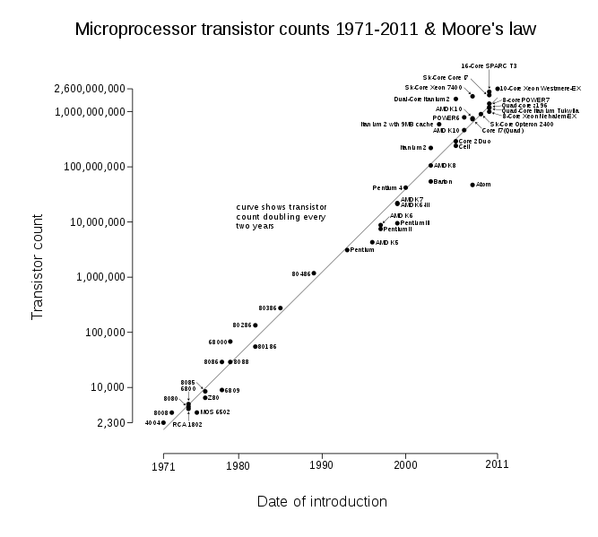C. Grafik Perkembangan Jumlah Transistor Product Intel dan Tahun Keluaran**

**D. Gambar Rangkaian Full Adder**

1. Gambar Pertama

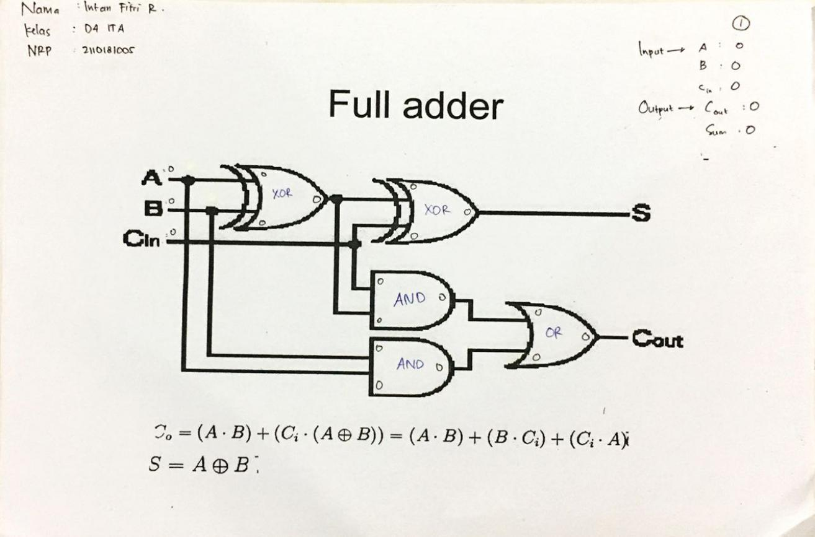

1. Gambar Kedua

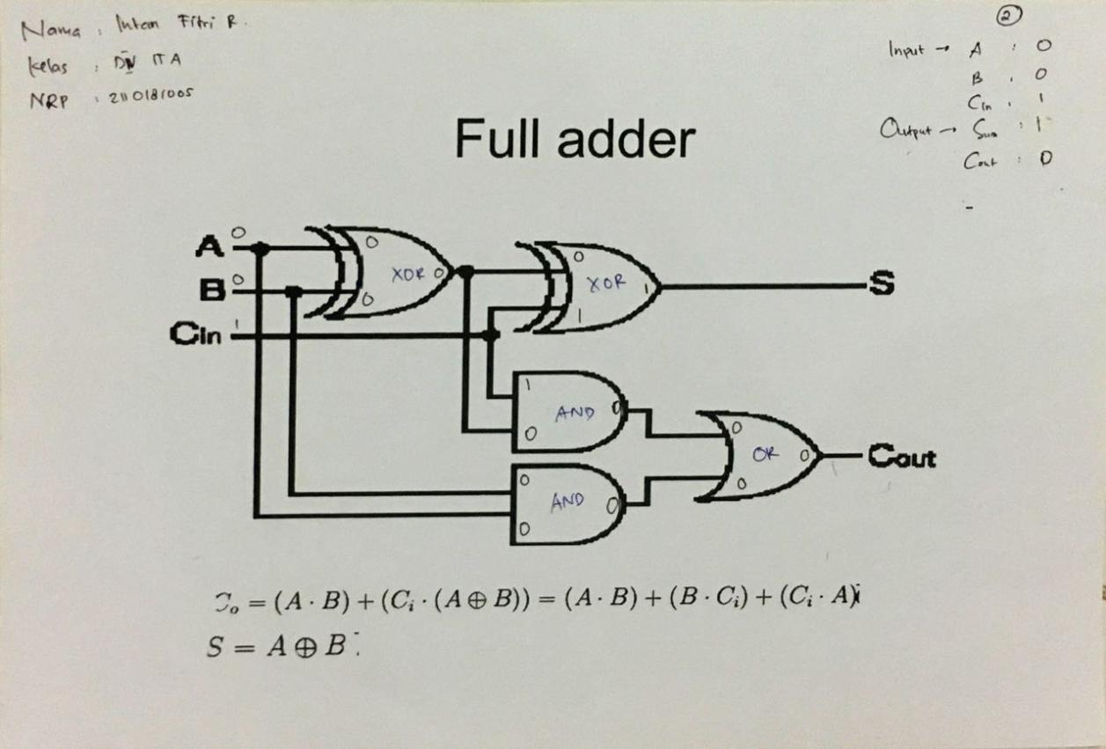

1. Gambar Ketiga

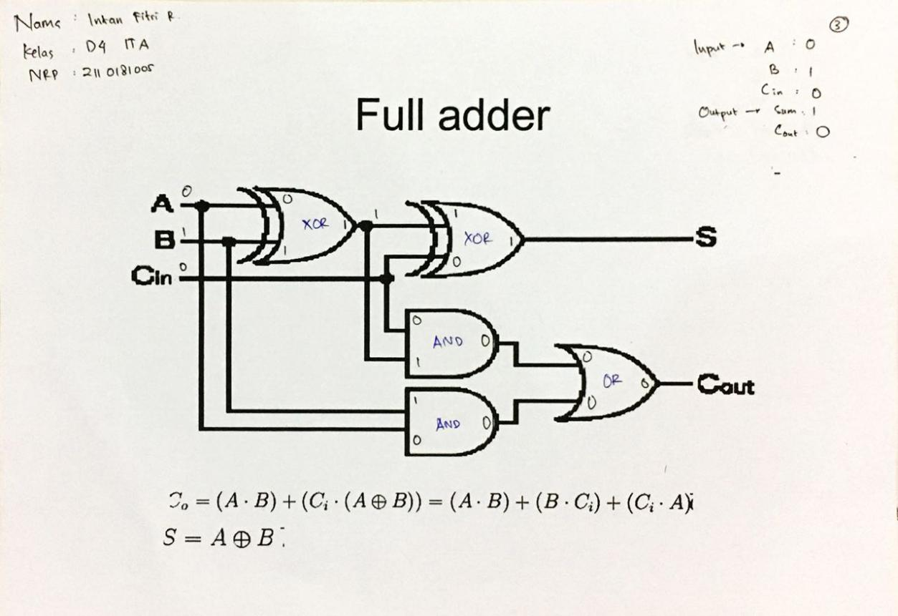

1. Gambar Keempat

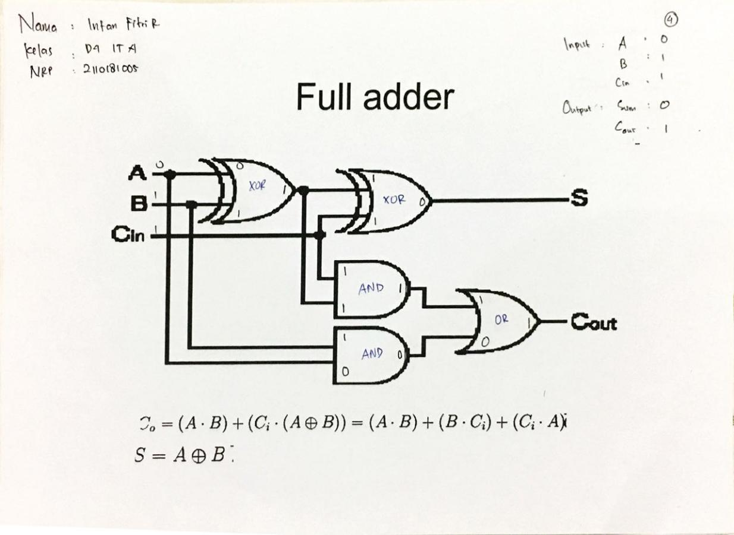

1. 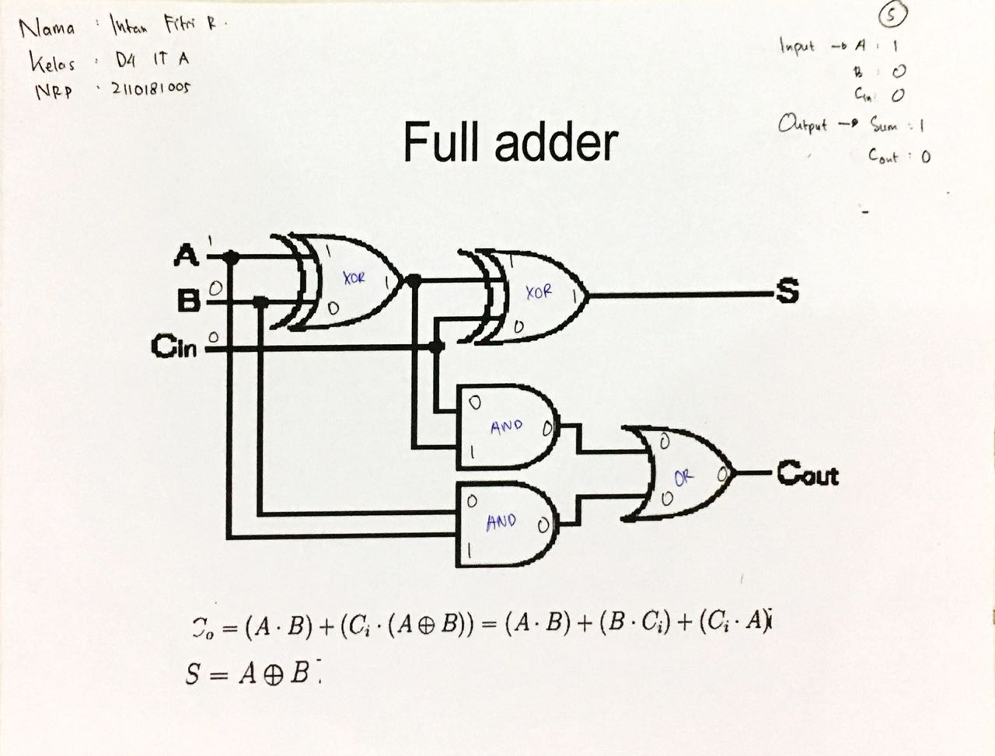Gambar Kelima
2. Gambar Keenam

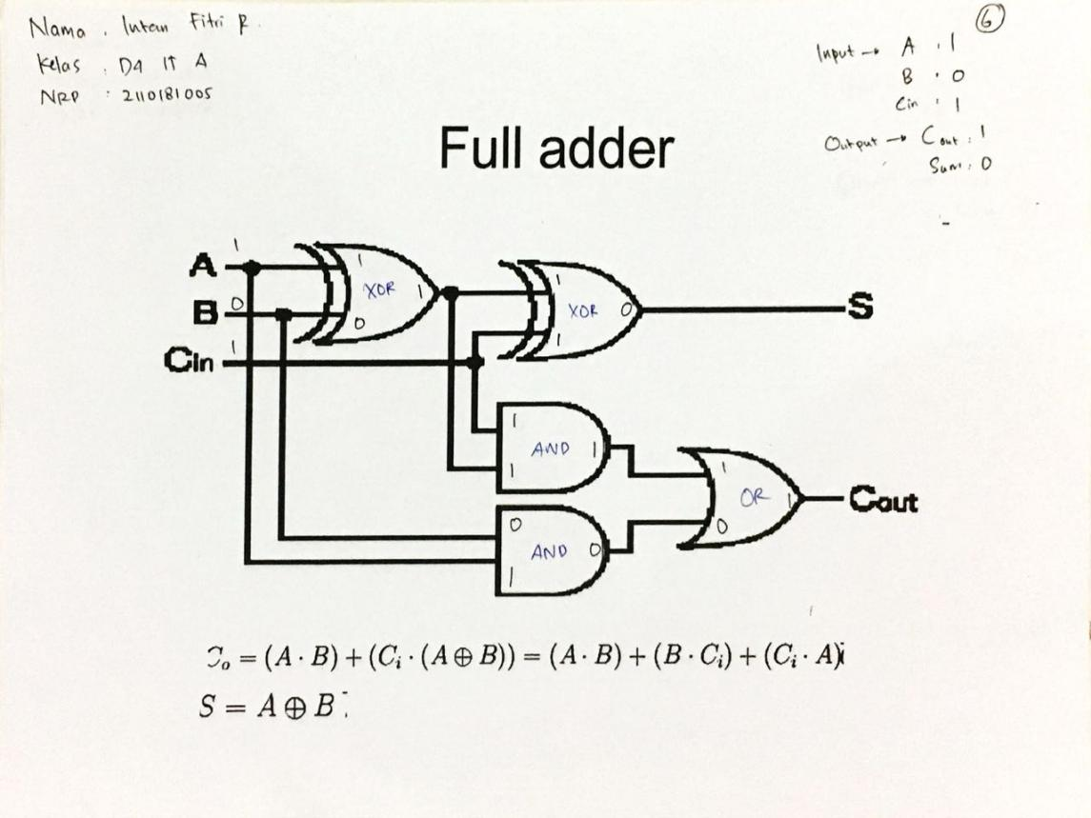

1. Gambar Ketujuh

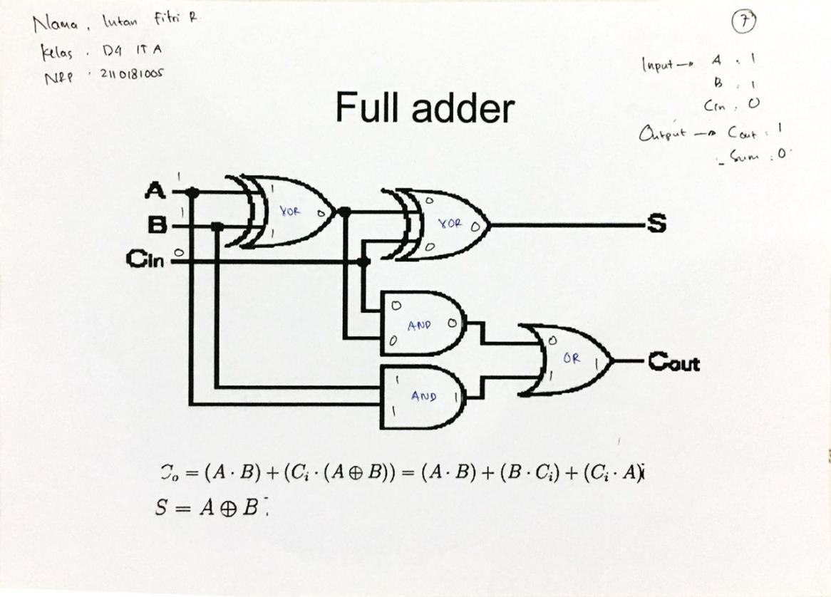

1. Gambar Kedelapan

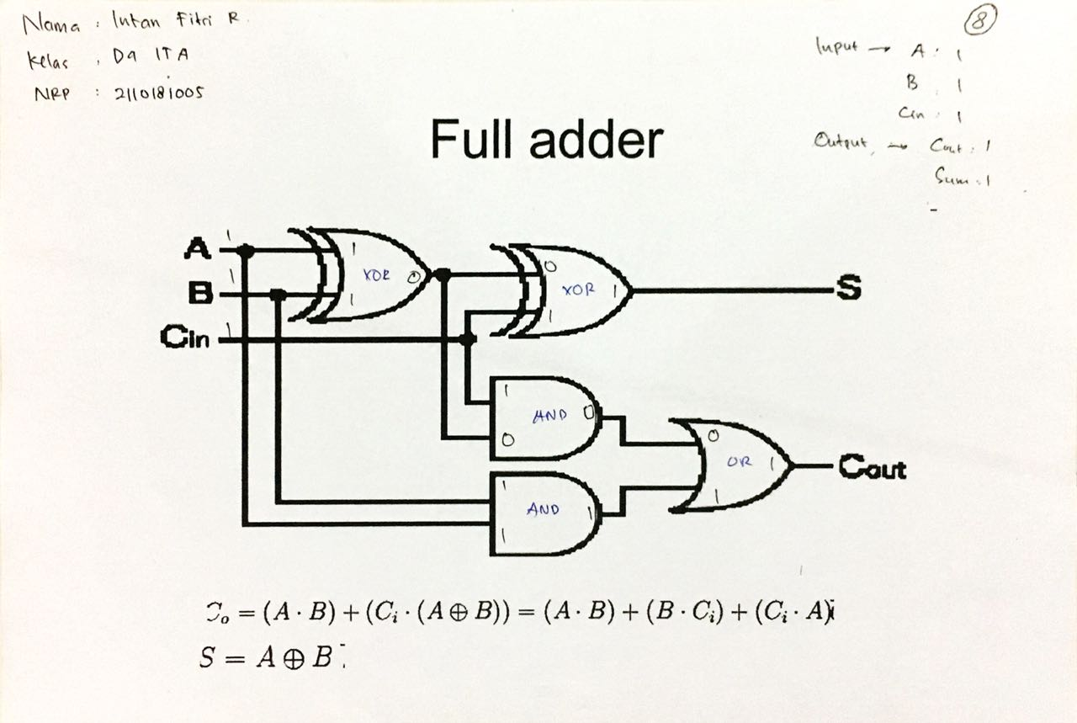

**E. Tabel Full Adder**

**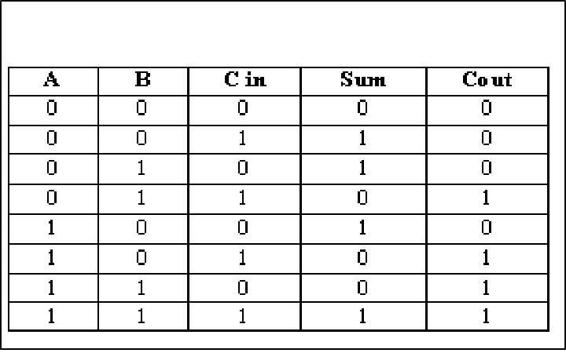**

Sumber :

<https://engineeringinsider.org/half-adder-full-adder/>

<https://allfilescomputer.blogspot.com/2013/10/gerbang-logika-half-adder-full-adder.html>

<https://id.wikipedia.org/wiki/Transistor>

<https://teknikelektronika.com/pengertian-transistor-jenis-jenis-transistor/>

<https://skemaku.com/sejarah-transistor-pada-perkembangan-teknologi-elektronika/>